**Listening Section**

**I. Pictures 看图辨义 – 24% 每题6分**

*Listen to the questions. Then choose the best answer according to each picture.*

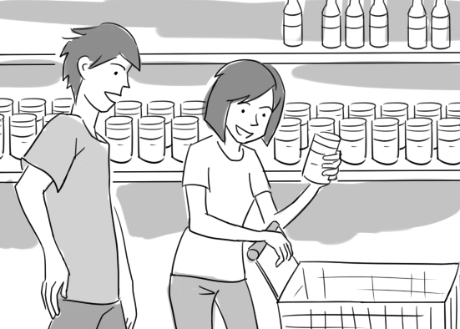**A.**

For questions number 1 and 2, please look at picture A.

**(B)** 1. What does the woman have?

A. A menu for a delicious meal.

B. A look of satisfaction on her face.

C. A basket full of vegetables.

D. A long shopping list in one hand.

**(C)** 2. What is the man probably saying?

A. How did they get broken?

B. Is it done cooking yet?

C. What does the label say?

D. Are you in the wrong row?

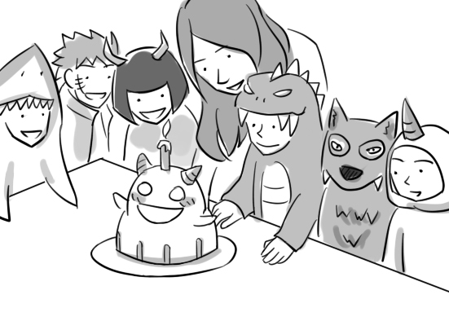**B.**

For questions number 3 and 4, please look at picture B.

**(A)** 3. What is true about this party?

A. It has a monster theme.

B. It’s being held by a pool.

C. It lacks decorations.

D. It’s ending very early.

**(D)** 4. What can we conclude about the woman?

A. She’s very underweight.

B. She’s getting homesick.

C. She’s quite disappointed.

D. She’s being attentive.

**II. Best Response 最佳回应句 – 28% 每题7分**

*Choose the best response to each question or statement.*

**(D)** 5. Why does Peter have a guilty conscience? (11/25-27)

A. He’s the nicest guy I know.

B. He’ll try to gain some weight.

C. He’s cooking a delicious meal.

D. He did something very wrong.

**(C)** 6. Since she recovered, Amy has had much more optimism about the future. (11/28)

A. Aren’t you phoning her?

B. Isn’t she able to come?

C. That’s good to hear.

D. Correct her gently.

**(D)** 7. This certificate still needs to be signed. (11/29, 30)

A. Are there any close to the bank?

B. It says highway number five.

C. When will it be installed?

D. I’ll do that right away.

**(B)** 8. What was the company’s revenue in 2012? (11/29, 30)

A. From June to October.

B. Twenty million dollars.

C. In a tall office building.

D. Several new managers.

**III. Short Conversations简短会话 – 24% 每题8分**

*Listen to the conversations. Then answer the questions.*

**(C)** 9. (11/25-27)

W: Where did you get these chairs?

M: I bought them from my friend Patricia. She originally wanted sixty dollars for them.

W: That’s a lot.

M: I know. I refused to pay that much, and she eventually halved the price.

W: Not bad.

Q: What did Patricia reduce the price to?

A. Fifty dollars.

B. Forty dollars.

C. Thirty dollars.

D. Twenty dollars.

**(A)** 10. (11/25-27)

M: Did you meet with the manager of the university bookstore?

W: Yes. I think I made a good impression.

M: That’s good. What kinds of questions did he ask?

W: Oh, the usual ones about my education and work experience.

M: Are there other applicants for the position?

W: Yes. I’ll find out whether I got it next week.

Q: What is the woman probably telling the man about?

A. A job interview. B. A class schedule.

C. A college course. D. A research report.

**(C)** 11. (11/29, 30)

W: What are you watching on TV?

M: The royal wedding.

W: Oh! Is that happening today?

M: Yes, right now. See? There’s the bride and groom.

W: Who’s the older lady in the white hat and blue dress?

M: Don’t you recognize her? She’s the head of the royal family!

W: Oh, of course. I wonder what it’s like to be royalty.

M: I’m sure it has its advantages.

Q: What is probably true about the woman in the blue dress?

A. She’s a singer. B. She’s a landlady.

C. She’s a queen. D. She’s a composer.

**IV. Short Talk 短文 – 24% 每题12分**

*Listen to the talk. Then choose the best answer to each question.*

A ***proverb*** says that one man’s trash is another man’s treasure. And believe me, it’s true. Several years ago, I had some old comic books that I no longer wanted. My friend offered to ***swap*** his pocket knife for them. I loved the knife, so in ***haste***, I accepted his offer. A week later, he told me that he had sold the comic books to a collector for $10,000. That experience ***discouraged*** me at first. Later, however, I came to view it as a ***blessing***, for it taught me to value the things that I own and not part with them lightly.

**(D)** 12. What did the speaker learn from this friend?

A. The value of the comics had decreased.

B. There was going to be a sale on comics.

C. None of the comics had ever been read.

D. The comics were worth a lot of money.

**(B)** 13. What does the speaker imply about this experience?

A. He feels anxious about it.

B. He learned a lesson from it.

C. He experienced it many times.

D. He forgot about it until recently.

**Reading Section**

**I. Vocabulary 词汇 – 36% 每题4分**

*Choose the word or phrase that best completes the sentence.*

**(A)** 1. The mayor’s actions were widely criticized, yet he insisted that his conscience was __________. (11/25-27)

A. clear B. brave

C. fluent D. scarce

**(D)** 2. Does the label on the __________ indicate how it should be cleaned? (11/25-27)

A. inquiry B. diploma

C. fortune D. scarf

**(C)** 3. According to this book, the __________ “sea change” and “salad days” were both coined by William Shakespeare. (11/25-27)

A. developments B. sympathies

C. expressions D. obstacles

**(C)** 4. We tried to comfort Lisa, but nothing could __________ her grief. (11/25-27)

A. stroke B. gesture

C. relieve D. attempt

**(D)** 5. According to this announcement, the theme of the __________ will be “Our Digital Future.” (11/25-27)

A. participle B. generosity

C. advantage D. convention

**(B)** 6. The kindness of the simple mountain folk made a __________ impression on me. (11/25-27)

A. missing B. lasting

C. demanding D. traveling

**(A)** 7. What were conditions in the countryside like during the czar’s __________?(11/29, 30)

A. rule B. fault

C. theme D. custom

**(A)** 8. It takes most students two years to __________ a certificate in adult education at that school. (11/29, 30)

A. earn B. pass

C. alert D. urge

**(D)** 9. Why are so many people __________ with British royalty these days? (11/29, 30)

A. participated B. enforced

C. varied D. fascinated

**II. Cloze Test综合测验 – 30% 每题5分**

*Read the passage and fill in each blank with the correct word or phrase.*

There is plenty of bad news these days. So it’s sometimes easy __(10)__ discouraged. Yet according to experts, it’s much healthier to maintain a positive attitude.

But how can you do it? Stop and think of all the things you are thankful for. You may be surprised by how many things you can think of. Being __(11)__ of your many blessings makes it easier to have a thankful attitude. Why is that important, though?

The __(12)__ of being thankful:

Grateful people are kinder and more likely to feel loved.

Thankful people have higher levels of __(13)__.

People who practice gratitude can increase their happiness by 25 percent!

Grateful people have lower levels of depression and stress.

People who are grateful place a low __(14)__ on material goods. Therefore they don’t waste their time and energy desiring what others have.

Thankful people __(15)__ greater satisfaction in life and more hope for the future.

Best of all, a thankful attitude inspires others to feel thankful, too.

**(B)** 10. A. feels B. to feel

C. be felt D. feeling

**(C)** 11. A. private B. dynamic

C. aware D. mutual

**(C)** 12. A. services B. manners

C. benefits D. legends

**(A)** 13. A. optimism B. settlement

C. regulation D. frequency

**(B)** 14. A. dislike B. value

C. item D. major

**(A)** 15. A. express B. headline

C. pardon D. defend

**III. Reading Comprehension阅读理解–25%每题5分**

*Read the paragraph. Then answer the questions.*

Throughout human history, people have employed a variety of materials as currency.

Metal: Many ancient civilizations used precious metals like gold and silver as money. At first they measured the metals by weight, but then they began creating coins. The earliest known coins, which were unearthed in modern-day Turkey, date back to the 7th century B.C.

Paper: During China’s Tang dynasty, the government started issuing certificates called “flying money” that could be exchanged for cash. The first official paper money was printed around 200 years later during the Song dynasty.

Shells: As early at the 16th century B.C., cowrie shells were used by people in China as currency. Cowrie shells were still used in Africa in the 20th century, making them the world’s longest and most widely used currency.

In North America, beads made from the shells of sea snails and salt-water clams were also an important currency for several centuries. Called wampum, the beads were strung together to make necklaces, bracelets and belts. When Europeans settled in North America in the 16th century, Native Americans were already using wampum, so the newcomers followed suit. The Europeans accepted strings of wampum in payment for metal products like knives and, in turn, used the wampum to pay for items the Indians sold. Wampum continued in use until the 18th century, when it was gradually replaced by silver.

Fur: In 17th-century Russia, hunters and trappers flooded into Siberia in search of fur, which they hoped would earn them great wealth. Some say fur accounted for over 10 percent of Russia’s revenue at this time. To take advantage of this trend, Russia’s czars set a tax that could only be paid in fur.

**(B)** 16. Which of the following is the best title for this article?

A. The Risks Associated With Major Currencies

B. A Look At Currencies Through The Ages

C. The Origins of the World’s oldest Currency

D. Currencies That Have Survived Economic Crises

**(D)** 17. According to this article, in which place were animal skins accepted as payment?

A. Turkey B. China

C. North America D. Russia

**(A)** 18. What did the Native Americans do in the 1500s?

A. Introduce their currency to immigrants

B. Reduce the value of a traditional currency

C. Keep their currency well hidden

D. Experiment with a variety of currencies

**(A)** 19. What does the article point out about wampum?

A. It was fashioned into jewelry.

B. It may become popular again.

C. It can be hard to manufacture.

D. It’s less portable than metals.

**(B)** 20. In which place did people first use bills in place of other materials for money?

A. Turkey B. China

C. North America D. Russia

**IV. Translation中译英 – 9% (每格1分)**

21. 在她极仓促之下，Mary忘记离家之前关闭冷气 机。(11/25-27)

**In her great haste**, Mary forgot to turn off the air conditioner before leaving home.

22. Andy相信乐观是有感染力的，所以他试着成为一 个快乐，积极的人。(11/28)

Andy believes **that optimism is contagious**, so he tries to be a happy, **positive** person.

**V. Bonus 加分题 – 10%**

23. 这袋的玛瑙贝你付了多少钱？(11/29, 30)

**How much money did you shell out for this package of cowrie shells?**