**Listening Section**

**I. Pictures 看图辨义 – 24% 每题6分**

*Listen to the questions. Then choose the best answer according to each picture.*

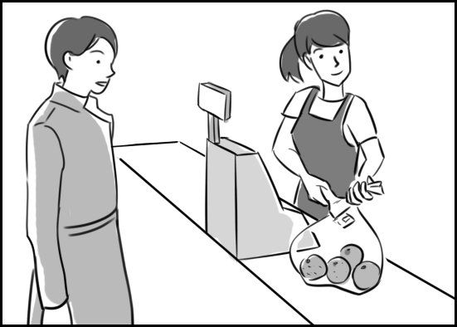**A.**

For questions number 1 and 2, please look at picture A.

**(B)** 1. What does the picture probably show?

A. A stand in a fruit market.

B. A supermarket check-out.

C. A fresh vegetable section.

D. A passenger ticket counter.

**(A)** 2. What is the man probably doing?

A. He's making a purchase.

B. He's borrowing cash.

C. He's trying to find a buyer.

D. He's filling store shelves.

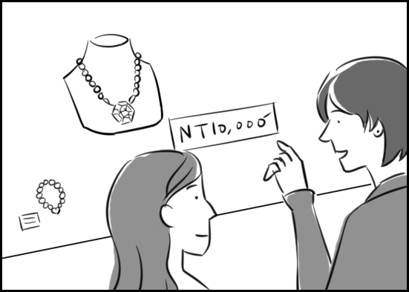**B.**

For questions number 3 and 4, please look at picture B.

**(C)** 3. What are these people looking at?

A. A dairy product.

B. A clothing article.

C. A jewelry item.

D. A small appliance.

**(C)** 4. What is the woman probably saying?

A. Look at the price of that scarf!

B. Who can afford such furniture?

C. That's way beyond my budget!

D. Would you buy such a big hat?

**II. Best Response 最佳回应句 – 28% 每题7分**

*Choose the best response to each question or statement.*

**(D)** 5. Is the bank charging Peter a high interest rate? (3/24, 25)

A. Yes, his former boss.

B. Yes, several years ago.

C. Yes, a good salary.

D. Yes, fifteen percent.

**(C)** 6. According to experts, this technology is going to revolutionize air travel. (3/26)

A. I've booked the flights.

B. The airport is rather far.

C. That's quite remarkable.

D. Here's a new list of fares.

**(A)** 7. Do you have any spices in your kitchen? (3/27-29)

A. Only sea salt and pepper.

B. Several heads of lettuce.

C. Beef, pork, and chicken.

D. Fresh eggs and butter.

**(C)** 8. This article by Professor Smith has some very useful grammar tips. (3/31)

A. Yes. He taught French history.

B. Sure. Buy a dozen for me, too.

C. Oh? I should read it sometime.

D. Really? That's a lot of money.

**III. Short Conversations简短会话 – 24% 每题8分**

*Listen to the conversations. Then answer the questions.*

**(A)** 9. (3/24, 25)

W: Hey, Peter. You still owe me NT$20,000.

M: I do?

W: Yes. That's how much you borrowed from me to pay your rent.

M: When?

W: About three weeks ago. You promised to repay it this month.

M: Oh, that's right. How could I forget?

Q: What are these people talking about?

A. A loan.

B. A job.

C. A date.

D. A gift.

**(D)** 10. (3/27-29)

M: What was that news report about?

W: A group of students who went hiking in a jungle in Central America. Two of them got separated from the rest of the group and are now missing.

M: Oh no.

W: And now a hurricane is approaching the area.

M: Let's hope they're found soon.

Q: What does the woman imply about the two students?

A. They're both heroes now.

B. They're extremely careful.

C. They're getting much praise.

D. They're in serious danger.

**(B)** 11. (3/31)

W: Look who's walking down the runway now!

M: Is that Elizabeth Davis?

W: Yes, it is, and look at the fur coat she's wearing.

M: Wow! I've never seen one quite like it.

W: Neither have I. Take a photo of her. Quick!

Q: Where are these people?

A. At a dance festival.

B. At a fashion show.

C. At an exercise class.

D. At a dinner party.

**IV. Short Talk 短文 – 24% 每题8分**

*Listen to the talk. Then choose the best answer to each question.*

Hi, Greg. This is Sam. I'm just calling to tell you about a special ***exhibit*** that's starting today at the National Gallery of Culture. The ***exhibit*** traces the history of ***cricket*** around the world. The ***budget*** for this show must be huge because it contains more than one thousand items. There are uniforms from the 1800s, ***exotic*** ***cricket*** bats and balls, and photographs of ***cricket*** stars past and present. Tickets for adults cost just five dollars. And with your ticket ***purchase***, you get a program guide and map of the ***exhibit***. I know you love ***cricket*** as much as I do. So why don't we go see this ***exhibit*** on Saturday? Let me know if you're interested. Bye!

**(C)** 12. Where does Sam want to go with Greg on Saturday?

A. To a busy factory.

B. To a movie theater.

C. To a local museum.

D. To a large bookstore.

**(C)** 13. What do Sam and Greg share an interest in?

A. An annual competition.

B. A world-famous band.

C. An international sport.

D. A traditional holiday.

**(B)** 14. What does Sam want Greg to do soon?

A. Check prices.

B. Return his call.

C. Contact friends.

D. Send him money.

**Reading Section**

**I. Vocabulary 词汇 – 30% 每题3分**

*Choose the word or phrase that best completes the sentence.*

**(D)** 1. For Tom, the __________ to eat another piece of candy was very strong. (3/24, 25)

A. enlargement B. check-out

C. assembly D. temptation

**(B)** 2. Some clever criminals were able to __________ my email account and steal some of my personal information. (3/24, 25)

A. object B. access

C. intend D. scoop

**(B)** 3. The huge drop in the stock market caused a severe __________ crisis. (3/24, 25)

A. generous B. financial

C. jealous D. exotic

**(D)** 4. You'd better have a __________ ready in case you aren't able to sell your house. (3/24, 25)

A. walk of life B. solar system

C. cutting edge D. backup plan

**(C)** 5. In some parts of the world, European __________ lasted for hundreds of years. (3/27-29)

A. population B. masterpiece

C. colonialism D. announcement

**(A)** 6. That poor family's __________ for food items is only about two hundred dollars a month. (3/27-29)

A. budget B. apology

C. purchase D. calculator

**(A)** 7. The museum's new sculpture ___________ is attracting a lot of people. (3/27-29)

A. exhibit B. gallon

C. curry D. manner

**(D)** 8. Flower arranging is a traditional __________ in Japan and other Asian countries. (3/27-29)

A. panel B. spice

C. razor D. craft

**(B)** 9. Some of the world's top models will walk down this __________ tomorrow wearing amazing dresses. (3/31)

A. consigner B. runway

C. survival D. glimpse

**(C)**10. Data is __________ between the computers at very high speeds. (3/31)

A. surrendered B. revolutionized

C. transmitted D. volunteered

**II. Discourse Structure 篇章结构 – 30% 每题6分**

*Read the passage and fill in each blank with the correct sentence.*

If you love jungles, white sandy beaches and interesting cities, then head for Sri Lanka. It's the perfect island for you!

Cricket is Sri Lanka’s most popular sport. (11)____________ But don’t stay in town too long. There’s more to see and do in the countryside! There you can ride a bike through Sri Lanka’s hill country. Visit some of the tea plantations in the mountains. (12)____________ You can also learn more about local culture and history in one of the old villages. For a little adventure, go on a jungle safari. (13)____________

Sri Lanka is also a shopping heaven, and the Pettah Bazaar in Colombo is a good place to start. This bazaar covers many streets. (14)____________ It’s a great place to wander around for an afternoon. Do you want to shop for something nicer? There are many high-end shopping areas throughout the city and beyond.

It’s time to relax after a long, busy day. Why not check out one of Sri Lanka’s beautiful beaches? Head south to find Unawatuna Beach. (15)____________ Or go farther to discover Mirissa Beach, an even quieter spot. Haven’t had enough adventure? Mirissa is also the place to go in search of a blue whale.

A. Each one has different items on display.

B. It’s known for its calm waters and cafés.

C. A great alternative is to tour a tea factory.

D. Try to get tickets to a match when you’re there.

E. You're sure to catch a glimpse of some wild creatures that are native to the area.

|  |  |  |  |  |
| --- | --- | --- | --- | --- |
| **11: D** | **12: C** | **13: E** | **14: A** | **15: B** |

**III. Reading Comprehension阅读理解–32%每题8分**

*Read the paragraph. Then answer the questions.*

In gene therapy, healthy genes are introduced into a person's defective cells to prevent or cure disease. While much of the research is in the beginning stages, some successes point to the real benefit of the therapy. In Italy, doctors have recently treated one genetic disease with gene therapy. This disease most often begins to destroy the brain when children are between one and two, stopping them from walking and talking. By inserting normal, healthy genetic material into a virus and then infecting the patients, the researchers can apparently cure the disease. The children given the therapy are now in kindergarten and living normal lives.

In the U.S., scientists have used gene therapy to treat LCA, a rare disease that robs people of their vision. In their research, the scientists injected a virus containing healthy genes into the eyes of patients with LCA. Prior to the operation, the patients had virtually no vision at all. But only weeks following the procedure, their vision began to improve. As a result, the patients were able to make their way through an experimental obstacle course without knocking things down. They were also able to read large text on signs and recognize human faces. The patients in the research were all adults, but the researchers believe the treatment may be even more effective in children.

Gene therapy has also been used to help older patients who suffer from a disease that causes slow movement and uncontrollable shaking because part of the brain dies. Those treated with gene therapy showed a 23.1% improvement when tested six months later.

**(C)** 16. Why is the disease studied in Italy serious?

A. It leads to weight gain in some kids.

B. It keeps the heart from beating properly.

C. It interferes with oral communication.

D. It helps infections spread quickly.

**(D)** 17. What was true about the U.S. patients prior to the study?

A. They didn't breathe well.

B. They had poor digestion.

C. They couldn't hear at all.

D. They were almost blind.

**(C)** 18. What do we learn about LCA from this article?

A. It's fatal in most cases.

B. It disappeared long ago.

C. It affects few individuals.

D. It may be caused by bacteria.

**(A)** 19. According to this article, what is gene therapy?

A. An emerging field of study

B. A topic that stirs fierce debate

C. An approach to foot and leg care

D. A treatment for muscle aches

**IV. Translation中译英 – 8% (每格1分)**

20. 我父母最近增加五百元到他们的紧急预备金。(3/24, 25)

My parents have recently added five hundred dollars **to their emergency fund**.

21. 依据有些专家所言，利率也许在2014下半年会提高。(3/24, 25)

According to some experts, **interest rates may rise** during the second half of 2014.

**V. Bonus 加分题 – 10%**

22. Paul为他家购买高档的视听设备有无法控制的欲望。(3/26; 27-29)

**Paul had an uncontrollable desire to buy____ more high-end audio equipment for his home.**