**Listening Section**

**I. Pictures 看图辨义 – 24% 每题6分**

*Listen to the questions. Then choose the best answer according to each picture.*

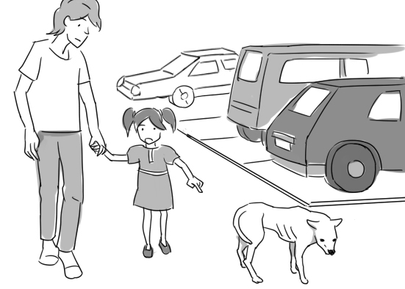**A.**

For questions number 1 and 2, please look at picture A.

**(D)** 1. Where are these people?

A. In a departure area.

B. In a school yard.

C. In a visitor center.

D. In a parking lot.

**(D)** 2. What is the little girl probably saying?

A. It looks like he’s getting more sleep.

B. Here’s my favorite illustration of a dog.

C. Why aren’t the cars stopping for us?

D. Should we take it to an animal shelter?

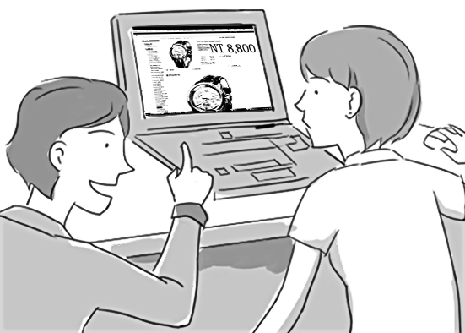**B.**

For questions number 3 and 4, please look at picture B.

**(B)** 3. What is the woman probably doing right now?

A. Printing a magazine.

B. Inspecting a website.

C. Using her office keys.

D. Closing her computer.

**(C)** 4. What is the man probably saying?

A. I’m surfing without you.

B. Stand still for a moment.

C. Now click on that arrow.

D. Put these packages away.

**II. Best Response 最佳回应句 – 28% 每题7分**

*Choose the best response to each question or statement.*

**(A)** 5. Are any of the appliances in that store discounted this week? (11/20, 21)

A. No, they’re full price.

B. No, the shop is open.

C. No, it’ll last ten days.

D. No, radios sell well.

**(D)** 6. What did you think of the potluck? (11/20, 21)

A. No one rehearsed mine.

B. I enjoyed the match.

C. It was simple to read.

D. The food was great.

**(A)** 7. It’s important for students to pay attention to personal hygiene. (11/22, 23)

A. That’s what I tell my children.

B. She’s their favorite teacher.

C. It won’t be on the next math test.

D. It isn’t easy to get good grades.

**(C)** 8. Paula and I both entered the lucky draw at the company party. (11/22, 23)

A. How could I forget your birthday?

B. Was there enough food for everyone?

C. Did either of you win anything?

D. Why will it be in the afternoon?

**III. Short Conversations简短会话 – 24% 每题8分**

*Listen to the conversations. Then answer the questions.*

**(C)** 9. (11/18, 19)

M: Excuse me.

W: Yes?

M: I’m gathering consumers’ opinions about the new comedy series that are showing on television this fall. Do you watch television?

W: Yes, I do.

M: Then could I ask you a few questions? It will only take a moment of your time.

W: Sure, I guess so.

Q: What is the man probably doing?

A. Enjoying a show.

B. Dating a woman.

C. Taking a survey.

D. Selling a TV.

**(B)** 10. (11/18, 19)

W: Who are you talking to on the phone?

M: A man at an insurance company. He says that we haven’t paid our car insurance yet this year.

W: Really?

M: Yes. He’s asking for my credit card number.

W: He must be a scam artist. I’m sure I paid that bill last month.

M: I’ll just hang up then.

Q: What does the woman imply about the man on the phone?

A. He can’t relax.

B. He isn’t honest.

C. He has a poor memory.

D. He pays in cash.

**(B)** 11. (11/22, 23)

M: Hi, Susan.

W: Oh, hi, Joe. How was your trip to Southeast Asia?

M: The trip was fine. But now that I’m back in the office, I feel exhausted all the time.

W: Do you have a fever?

M: I seem to, and I have chills sometimes too.

W: Hmm. Those sound like symptoms of malaria. Did you take pills for that?

M: No, I didn’t.

Q: What does the woman think may be the man’s problem?

A. Depressed feelings.

B. A serious disease.

C. Work pressure.

D. Loneliness.

**IV. Short Talk 短文 – 24% 每题8分**

*Listen to the talk. Then choose the best answer to each question.*

Hello, Mr. Lee? This is Ted Nelson. I’m the leader of the ***boy scout*** troop to which your son belongs. With summer just ***around the corner***, we’re planning a camping trip for the boys. Your son often mentions your camping skills, so I’d like to invite you to join us. We’ll leave next Friday evening from the ***parking lot*** of Jones High School and drive to Mountain Park. We’ll camp there for two nights and ***afterward*** return on Sunday evening. The boys are ***eager*** to go camping, so I’m sure we’ll have fun. If it’s not too ***troublesome***, can you let me know today whether you can come? You can reach me at 2455-3388. Thanks a lot! Goodbye.

**(A)** 12. When will this activity probably take place?

A. In early June.

B. In late August.

C. In the middle of September.

D. At the end of March.

**(B)** 13. What will the boys probably need this weekend?

A. Their tennis equipment.

B. Tents and sleeping bags.

C. Good library resources.

D. Reservations on a flight.

**(C)** 14. What does Ted Nelson tell Mr. Lee in this message?

A. Why he’s declining Mr. Lee’s invitation.

B. What Mr. Lee should plan to wear.

C. How soon he’d like Mr. Lee to contact him.

D. How he’ll recognize Mr. Lee this weekend.

**Reading Section**

**I. Vocabulary 词汇 – 36% 每题4分**

*Choose the word or phrase that best completes the sentence.*

**(C)** 1. The baseball player’s reputation was __________ when it was found that he had taken illegal drugs. (11/18, 19)

A. contributed B. shortened

C. destroyed D. frowned

**(B)** 2. Has it been announced when the next art auction will be __________? (11/18, 19)

A. solved B. held

C. owed D. elected

**(C)** 3. The __________ that wolves only kill sick and injured animals is nothing more than a myth. (11/18, 19)

A. charm B. verse

C. belief D. pitch

**(A)** 4. When I go shopping, I try to __________ the impulse to buy expensive clothes. (11/18, 19)

A. resist B. guard

C. stitch D. appeal

**(A)** 5. That retail __________ operates more than two hundred stores around the country. (11/20, 21)

A. chain B. merit

C. scale D. field

**(D)** 6. During her meeting with the lawyer, Amy __________ gratitude for his kind assistance. (11/20, 21)

A. succeeded B. minored

C. launched D. expressed

**(D)** 7. In our history course, we studied the underlying __________ of the rebellion that took place in Russia during 1606 and 1607. (11/20, 21)

A. shore B. grave

C. angle D. cause

**(B)** 8. No enough __________ was paid by the workers to personal hygiene. (11/22, 23)

A. logic B. attention

C. importance D. criticism

**(C)** 9. Proceeds from the charity event __________ to nearly USD200,000. (11/22, 23)

A. networked B. supported

C. amounted D. Financed

**II. Cloze Test综合测验 – 30% 每题5分**

*Read the passage and fill in each blank with the correct word or phrase.*

Thanksgiving is coming soon. This holiday not only __(10)__ football and turkey but also helps us remember to be thankful. Traditionally Americans go home for Thanksgiving. So people start preparing weeks before the holiday. Excited moms are __(11)__ to have their children come home.

Thanksgiving is also a season for giving. Irene’s school has a “Turkey Trot” race every year around Thanksgiving. You can give small amounts of money for __(12)__ to run in the race. In our neighborhood, the Boy Scouts go door-to-door asking for canned food for the __(13)__. Churches and charities sponsor coat drives for families who need winter coats. Some teen groups volunteer at homeless __(14)__ on weekends. They either prepare food or help serve it.

What does our family do? We usually go to our church __(15)__. The dishes are mostly Chinese, but the church prepares turkeys and pumpkin and apple pies. Afterward, we sing and share what we are thankful for in the past year.

**(D)** 10. A. supports B. estimates

C. monitors D. involves

**(A)** 11. A. eager B. legal

C. aware D. modern

**(B)** 12. A. lifetime B. charity

C. intention D. portrait

**(D)** 13. A. needing B. need

C. needed D. needy

**(C)** 14. A. routines B. demands

C. shelters D. budgets

**(A)** 15. A. potluck B. transfer

C. forecast D. mortgage

**III. Reading Comprehension阅读理解–25%每题5分**

*Read the paragraph. Then answer the questions.*

The most difficult computing tasks are often performed on supercomputers. While these machines are powerful, they are also very costly to build and operate. For this reason, many organizations use a lower-cost approach called “distributed computing,” which harnesses the spare power of millions of ordinary personal computers. One such organization is Charity Engine. It offers a free computer program. After people download and install it on their computers, it does research as a background task. The program runs automatically, without direction from the user. Each computer works on a small chunk of a large research project and sends back its results. The results are combined to answer the researchers’ questions.

Charity Engine mostly uses its computing power for companies doing scientific, medical or commercial research. For example, Rosetta@home attempts to help find cures for serious diseases by discovering the shapes of proteins. Another project, Einstein@home, tests scientific theories. And another helps establishments in Africa such as universities search for ways to fight the spread of malaria.

Charity Engine doesn’t pay people to download and run its app on their computers, so it must find other forms of motivation. One way it attract users is by giving 50 percent of the money that it earns to charities, such as Oxfam, CARE and Doctors Without Borders. Each organization it supports has a good reputation for working in an area of vital importance.

Charity Engine also attracts users by returning the other 50 percent of its earnings to them in the form of prizes. Each person who uses its app is entered into drawings. Chosen at random, the winners receive thousands of dollars.

**(C)** 16. According to this article, how is distributed computing superior to supercomputers?

A. It saves wear and tear.

B. It works a lot faster.

C. It’s less expensive.

D. It’s more reliable.

**(A)** 17. What is true about two of the companies that Charity Engine does work for?

A. They’re trying to solve medical problems.

B. They’re focusing attention on climate concerns.

C. They’re struggling to stay in business.

D. They’re both in the publishing industry.

**(A)** 18. What does Charity Engine do with personal computers?

A. It assigns part of a job to each one.

B. It donates them needy individuals.

C. It ships them all over the world.

D. It uses them to train its employees.

**(C)** 19. How does Charity Engine attract users?

A. By offering discounts.

B. By helping them interact.

C. By arranging contests.

D. By protecting their data.

**(B)** 20. According to this article, what does Oxfam receive from Charity Engine?

A. Electronic items

B. Financial support

C. Cheap advertising

D. Professional advice

**IV. Translation中译英 – 9% (每格1分)**

21. Sara的生日正好即将来临，所以我们应该开始帮 她计划一个派对。(11/20, 21)

Sara’s birthday is **just around the corner**, so we should begin planning a party for her.

22. 在你写完电子邮件之后，按下这个按钮寄出它。 (11/20, 21)

After you finish composing your email, **click on this button** to **send** it.

**V. Bonus 加分题 – 10%**

23. 在那黑暗的停车场留下昂贵的车子隔夜是冒险 的。(11/18, 19; 20, 21)

**It’s risky to leave an expensive car in that dark parking lot overnight.**