最后归纳

FORMULA CHEAT SHEET
- Density=mass/volume
- q=mc△T
- Spontaneity:△G=△H-T△S
△G <０ means that a reaction is spontaneous at this temperature
△H＞0，Endothermic
△H＜0，Exothermic
- △T=km (Freezing point depression & Boiling point depression)
k: solvent constant m: molality
- molarity=moles solute ÷ volume of solution
molality= moles solute ÷ mass of solvent
mole fraction = moles solute ÷total of solution
- Indeal Gas Law: PV=nRT
- Conversion
1 atm=760 torr = 760 mm Hg
1 Caloric = 4.18 joules
0℃=273k
- Facts to Know
•. find the mass of a mole of a substance, multiply the formula weight by the number of moles.
• 1 mol of gas at STP occupies 22.4L. of volume

- Solubility
Ag, Pb. Hg, Salts are insoluble
• Ground 1 metal salts are soluble
• All nitrates and perchlorates are soluble (even Ag, Pb, Hg)
• All neutralizations go to completion
- Oxidation Rules
1. When oxygen is in a compound, its oxidation state is usually -2 (it has been reduced). One important exception is oxygen in a peroxide such as hydrogen peroxide (H2O). In a peroxide, oxygen has an oxidation slate of-1.
2. When an alkali metal (Li, Na, etc.) is involved in a compound, its oxidation state is always +1 (it’s been oxidized).
3. When an alkali earth metal (B,Mg etc.) is involved in a com1ound, its oxidation state is +2.
4.when a halogen (F. Cl. etc.) is involved in a compound. its oxidation state is often -1. The oxidation state of fluorine in a compound is always - 1.
5. When hydrogen is combined with a nonmetal its oxidation state is +1. When hydrogen is combined with a metal its oxidation state is-1.
6. In any compound. the sum of all oxidation states is zero.

- Prefixes for Organics
Eth - 1
Meth-2
Prop-3
But -
Pent-5
Hex - 6
Hep - 7
Oct-8
Non - 9
Dec-10
- Prefixes for Scientific Notation
nano n 10-9
micro  10-6
milli m 10-3
centi c 10-2
kilo k l03
mega M 106
- Electrochemistry
OLE—Oxidation is losing electrons.
RIG—Reduction is gaining electrons .
AN OX—Oxidation occurs at Anode
RED CAT—Reduction occurs at Cathode.
Galvanic cell: Ecell＞０，spontaneous and energy is released.(battery)
Electrolytic Cell: Ecell＜0，not spontaneous and requires a voltage scurce.(electro palting)
- Equilibrium
aA+bBcC+dD
Keq=$\frac{[C]^{c}[D]^{d}}{[A]^{a}[B]^{b}}$
Keq＞０,product favored
Keq＜０,reactant favored
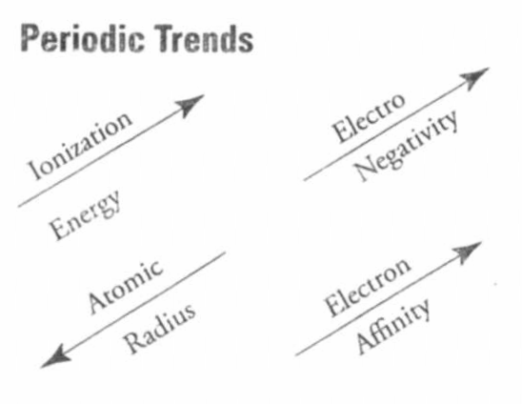
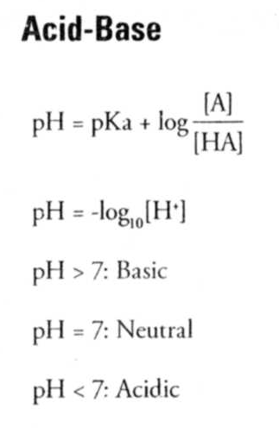
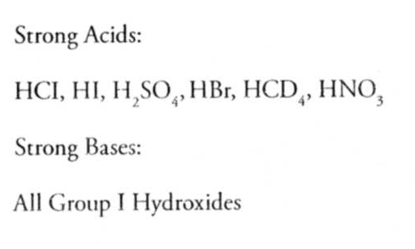
- Summary of molecular shapes
Linear
Bent
Trigonal-planar
Tetrahedral
Trigonal-pyramidal
Trigonal-bipyramidal
Octahedral
- PHASE CHANGE
solid and gas :sublimation deposition
solid and liquid: melting freezing
liquid and vapor: condensation vaporication
- WATER MIXTURES
solution
colloid
suspension
- Dissolubility
miscible
immiscible
soluble
insoluble
- COLLIGATIVE PROPERTIES
vapor pressure
freezing point decrease
boiling point increase
- Chemical reaction
combination / synthesis
decomposition / analysis
single replacement / single displacement
double replacement / double displacement
combustion reaction
substitute reaction
addition reaction
elimination reaction
oxidization reaction
reduction reaction
- Definition of acid and base
Arrhenius: acid—H＋ producer; base—OH- producer
Bronsted-lowry: acid—H＋ donor; base—H＋ acceptor
Lewis: acid—electron-pair acceptor ; base—electron-pair donor.
- Hydrocarbons
alkane
cycloalkane
alkene
aldyne
aromatic
- HYDROCARBONS DERIVATIVES
alcohol
aldehyde
organic acid or carboxylic acid
ketone
ether
amine
amino
amide
- Indicators
methyl orange
bromthymol blue
litmus
phenolphthalein
- operation 操作
filtration 过滤
distillation 蒸馏
evaporation蒸发
extraction 萃取
titration 滴定
chromatograph 色谱分离
spectrophotometer分光光度计
flame test焰色实验
- scientist 科学家
Dalton
Thomson
Robert Millikan
Rutherford
Niels Bohr
Mendeleev
Einstein
- gas law 气体定律
Avogadro’s law
Boyles’s law
Charles’s law
Combining
Conservation of Energy
Conservation of mass
Daltion’s matter
Daltion’s law of partical pressure
Definite composition
Faraday’s law
Fist law of thermodynamics
Gay-lussac’s law
Graham’s law
Henry’s law
Hess’s law
Indeal Gas
Multiple proportions
Periodic
Second law of thermodynamics
LeChatelier’s principle
- factors affecting reaction rates
the nature of reactant
the surface area exposed
the concentration
the temperature
the presence of catalyst
- compare 1
isotope 同位素
allotrope同素异形体
isomer同分异构体
homolog 同系物
- compare 2
mass number
atomic number
number of protons
number of neutrons
number of electrons
- compare 3
Dalton’s model道尔顿模型
Thomson’s model汤姆生模型
Rutherford’s mode卢瑟夫模型
Niels Bohr’s mode玻尔模型
现代模型(电子去模型)
- compare 4
intramolecular bond and intermolecular bonds
ionic bonding /covalent bonding/ coordinate covalent bonding/metallic bonds
dipole force / London dispersion force (Van Der waals force)/hydrogen bonding/molecule-ion attraction force
sigma and pi bonds
- compare 5
network crystal/ ionic crystal/ metallic crystal/ molecular crystal
- compare 6
Standard temperature and pressure
gas: 0℃ 1atm
thermochemistry：25℃ 1atm
- compare 7
chemical formulas
molecular formulas
true formulas
empirical formaulas
- compare ８
alkali metal 碱金属
alkaline-earth metals 碱土金属
noble gas 稀有气体元素
halogen 卤素
transition element 过渡元素
lanthanide series 镧系
actinium series 锕系
- compare ９
endothermic 吸热
exothermic 放热
homogeneous均一的
heterogeneous 非均一的
- compare 10
law of definite composition
law of multiple proportions
- equilibrium constant
Keq
Ka
Kb
Ksp
Kw
- electrolytes
good (strong electrolytes)
moderate
poor (weak electrolytes)
- resonance structures
SO₂
SO₃
C₆H₆
- hybridization杂化
sp :CO₂ CH≡CH BeCl2
sp2 :CH₂=CH₂ C₆H₆ graphite
sp3: CH₄ H₂O NH₃ diamond
- sublimation升华
dry ice（CO₂ ）干冰
iodine 碘
naphthalene ball卫生球
- element 元素
metal 金属
nonmetal 非金属
amphoteric 两性
- colour颜色
NO2
F2
Cl2
I2
Cu(OH)₂
Cu^{2＋}
Fe^{3＋}
MnO4-

