Listening Section
I. Pictures 看图辨义 – 24% 每题6分
Listen to the questions. Then choose the best answer according to each picture.

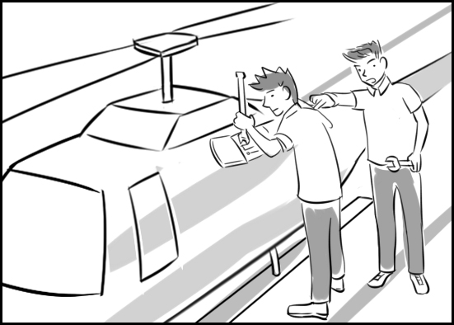
A.

1. ( )

2. ( )

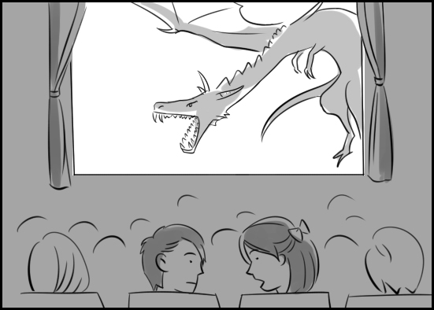
B.

3. ( )

4. ( )

II. Best Response 最佳回应句 – 28% 每题7分
Choose the best response to each question or statement.

5. A. OK, I'll take the phone call.
B. Yes, we have a daughter, too.
C. Did he do his homework?
D. Oh? What page is that on?

6. A. No, it's not far from here.
B. No, I already have a job.
C. No, we're on the wrong floor.
D. No, in fact it's gone down.

7. A. Yes, he's completing a report.
B. Yes, he's trying to catch a taxi.
C. Yes, he's standing in a ticket line.
D. Yes, he's biking instead of driving.

8. A. Pets like that are popular now.
B. It's quite comfortable to sit on.
C. Why not? It's a healthy vegetable.
D. It'll probably need a few repairs.

III. Short Conversations简短会话 – 24% 每题8分
Listen to the conversations. Then answer the questions.

9. A. A top medical expert.
B. An experienced author.
C. A language instructor.
D. An executive secretary.
10. A. At the entrance to a museum
B. Near an airport gate
C. In the lobby of a hotel
D. Beside a bus stop

11. A. Watch a film.
B. Take a trip.
C. Share a meal.
D. Play a sport.

IV. Short Talk 短文 – 24% 每题 8 分
Listen to the talk. Then choose the best answer to each question.

12. A. Along a busy road
B. Beside a mountain peak
C. In a farming area
D. Over a body of water

13. A. It was accompanied by some noise.
B. It got brighter after a few days.
C. It was shining on an office tower.
D. It changed color several times.

14. A. A light inside a bus
B. A light on an aircraft
C. A light produced by a star
D. A light from a building

Reading Section
I. Vocabulary 词汇 – 40% 每题 5 分
Choose the word or phrase that best completes the sentence.

1. The pants were too long for Kevin, so he took them to a tailor to have them __________.
A. relied B. altered
C. grieved D. occupied

2. When I arrived at the truck repair shop, the __________ were taking their lunch break.
A. misfortunes B. contrasts
C. timbers D. mechanics

3. If __________ visited our planet, would they be friendly or not?
A. lungs B. fares
C. diaries D. aliens

4. Scientists believe that there is a black hole at the center of our __________.
A. rescue B. violation
C. galaxy D. knight

5. We must do our best to __________ calm discussion between the opposing parties.
A. season B. facilitate
C. overflow D. disagree

6. After several dates for the staff party were proposed, James expressed his __________ for the last one.
A. masterpiece B. nightmare
C. circumstance D. preference

7. Why is it so difficult for Susan to get along with her __________ at the medical laboratory?
A. colleagues B. anxieties
C. exposures D. brownies

8. As we drove through the tiny town, we passed some old men __________ on chairs beside the road.
A. lounging B. sacking
C. disgusting D. recognizing

II. Passage Completion文意选填 – 30%每题 3分
Read the passage and fill in each blank with the correct word or phrase.

When I was a student living with a host family in America, two of my most remarkable (9)______ were Thanksgiving and Christmas. Thanksgiving, a traditional American festival, (10)______ the family gets together and has a feast. I tried a lot of food (11)______ I’d never had before. They (12)______ mashed potatoes, turkey and zucchini. Everything was very tasty. Then it was Christmas. We had an enormous dinner on Christmas Eve. Then we sat in front of the fireplace (13)______ my host father told me the story of Jesus’ (14)______. After that we gave each other presents and chatted. It was great!
Besides enjoying their cultural events, I shared some of (15)______ with them. I introduced Mid-Autumn Festival to them; (16)______ I made pineapple cakes and served tea. We watched the moon (17)______! At Chinese New Year, I prepared a traditional meal for them. One dish was dumplings. After I taught them how to (18)______ them, we did it together!
I am glad I got to enjoy their culture and share some of my own.

(A) as well (B) birth (C) experiences
(D) included (E) wrap (F) means
(G) mine (H) that (I) as
(J) afterwards

III. Reading Comprehension阅读理解–21%每题7分
Read the paragraph. Then answer the questions.

Memorandum

To: All office staff
From: Laura Sanderson
Date: June 5, 2014
Subject: Office manners

I have recently received complaints about our open office plan. Most of them center around things our colleagues do that disturb our concentration. Now that we are all working in cubicles, I would like to discuss office manners:
- Respect your neighbor's privacy. Do not enter his or her cubicle unless you are invited, and don't lean over cubicle walls to speak to others.
- Keep noise levels down so that all of us can concentrate on our work.
- Some of us have extremely sensitive noses, so enjoy your noon meal in the lunch room, not in your cubicle.
- If you don't want to be interrupted, put a "Do Not Disturb" sign by the entrance to your cubicle.
- Remember that every cubicle is a reflection of the person who inhabits it. So keep yours clean and tidy.

19. What does this memorandum mainly contain?
A. Rules for using company equipment
B. Instructions for meeting work deadlines
C. Guidelines for proper personal behavior
D. Suggestions for obtaining raises and promotions

20. Who probably wrote this memorandum?
A. A junior accountant
B. A retired politician
C. A qualified mechanic
D. A head supervisor

21. What does one of the points in this memorandum address?
A. Salary disputes
B. Annoying smells
C. Legal matters
D. New dress codes

IV. Translation中译英 – 9% (每格1分)

22. 我们如何判断出由那些农夫所种植出的水果是天然的或是基因改造的？
How can we determine whether the fruit grown by those farmers is __________ __________ __________ __________?

23. 甚至对于经验丰富的机师而言，要停降这台大规模的直升机并非简单之事。
It isn't easy for even an experienced pilot __________ __________ __________ __________ __________.

V. Bonus 加分题 – 10%

24. 在中秋节时会举办哪些种类的文化活动？
______________________________________________________________________________
Listening Section
I. Pictures 看图辨义 – 24% 每题6分
Listen to the questions. Then choose the best answer according to each picture.

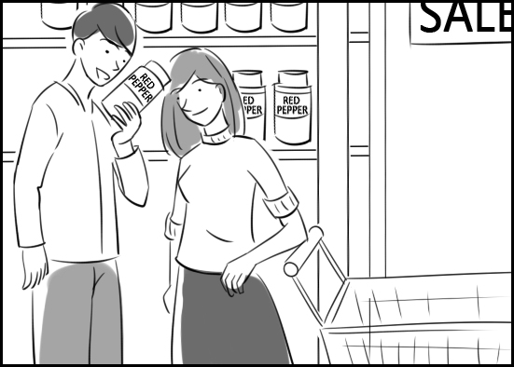
A.

1. ( )

2. ( )

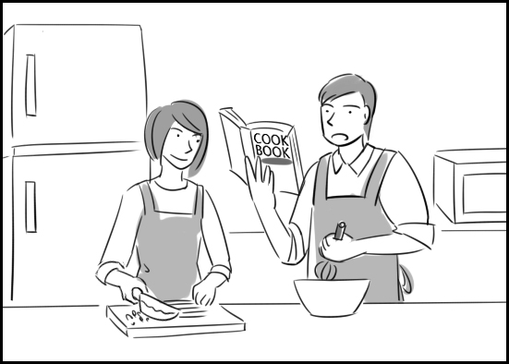
B.

3. ( )

4. ( )

II. Best Response 最佳回应句 – 28% 每题7分
Choose the best response to each question or statement.

5. A. Yes, they own a small restaurant.
B. Yes, they're both majoring in art.
C. Yes, they take the MRT to work.
D. Yes, they'll get married in the fall.

6. A. Food and medicine.
B. In 1990.
C. American, I think.
D. By a doctor.

7. A. It's published four times a month.
B. I know someone I can recommend.
C. There's a stack of them on the table.
D. You clearly enjoy the fashion news.

8. A. Yes. There might be a big sale.
B. Ok. I don't mind driving at all.
C. Really? Is the concert starting?
D. Sure. How about onion rings?

III. Short Conversations 简短会话– 24% 每题8分
Listen to the conversations. Then answer the questions.

9. A. At a motel. B. At a bank.
C. At a college. D. At a store.
10. A. Dancers. B. Beauty queens.
C. Musicians. D. Huge balloons.
11. A. He thought it was offensive.
B. He insisted on hearing it again.
C. He appreciated its creativity.
D. He gave it mild approval.

IV. Short Talk 短文 – 24% 每题 12 分
Listen to the talk. Then choose the best answer to each question.

12. A. Sports. B. Animals.
C. Hobbies. D. TV shows.
13. A. Your photo. B. Your hike.
C. Your picnic. D. Your car.

Reading Section
I. Vocabulary 词汇 – 30% 每题 3 分
Choose the word or phrase that best completes the sentence.

1. In their wedding __________, Sam and Judy promised to love each other forever.
A. gears B. palms
C. vows D. strokes
2. Among the larger __________ in this region are deer and bears.
A. tortoise B. wildlife
C. glimpse D. revenge
3. Perhaps the National Theater would be a good __________ for the new play.
A. excursion B. leaflet
C. hawk D. venue
4. That company was __________ by a group of investors in 1988.
A. rhymed B. founded
C. yawned D. decided
5. The situation at the factory is rather ___________, so I'll need some time to explain it to you.
A. complicated B. supposed
C. annoyed D. fascinated
6. Amy will find several excellent __________ for chicken soup in that cookbook.
A. recipes B. swords
C. unities D. parcels
7. Please stop __________ about your homework and finish it right now!
A. earning B. paving
C. burying D. whining
8. I was filled with __________ when I saw the terrible conditions in which those poor people had to live.
A. panel B. timber
C. disgust D. monk
9. Joe's favorite ___________ are onion rings and potato skins.
A. liquors B. immigrants
C. appetizers D. passages
10. This restaurant is known for its delicious German __________.
A. tribe B. fare
C. scene D. code
II. Discourse Structure篇章结构 – 30%每题 6 分
Read the passage and fill in each blank with the correct sentence.
In the past, traditional weddings in a church or civil ceremonies at a court were usually the only options. But these days, some people are choosing something more exciting — destination weddings. (11)____________.
Where do they go? Take a look!
Scotland has the very best picturesque and historic wedding destinations. Comlongon Castle in southwest Scotland is a 15th century castle. The groom and guests are escorted by a bagpiper into the 600-year-old Great Hall. (12)____________ The bride follows, and in this truly romantic setting, she and her groom marry.
A wedding on Bali would be a dream come true for many. (13)____________ Its wedding packages offer pre-wedding beauty treatments along with massages, professional hair and makeup sessions, wedding cakes, tropical flowers, traditional entertainment and more.
If the bride and groom want to be married indoors, they can choose between Tresna and Astina, a pair of sparkling glass chapels. (14)____________ If an outdoor wedding is preferred, they can marry on a cliff overlooking breathtaking Jimbaran Bay.
(15)____________ For them, a safari-themed wedding in South Africa can provide a once-in-a-lifetime experience. Sabi Sabi Private Game Reserve, located in Kruger National Park, offers luxurious lodgings and world-famous safaris.
A. Both offer marvelous views of the Indian Ocean.
B. One of the island's resorts is in the dream-making business.
C. Such an event involves traveling to a unique location with friends and family and celebrating there.
D. Some couples seek adventure.
E. Lit only by candles, it features a roaring fire in a fireplace.
III. Reading Comprehension阅读理解–30%每题6分
Read the paragraph. Then answer the questions.
Homeless people who want to make money can apply for a job selling a magazine called The Big Issue. First, they must prove they're homeless or soon will be. After training, they each receive 10 free copies of the magazine which sell for NT$100 each. With the money they make, they buy more magazines for NT$50 each. The more magazines they sell, the more they earn.
In 1991, John Bird and Gordon Roddick, of the United Kingdom, wanted to help homeless people. They established an organization called The Big Issue Foundation and began publishing The Big Issue, a monthly magazine that homeless people could sell. Its appealing content made people want to buy and read it. The idea spread around the world. In Taiwan, for example, magazine editor Fines Lee published Taiwan’s first copy of The Big Issue in April, 2010. “Instead of giving the homeless money,” Lee says, “we provide them with a way to help themselves … and we encourage the public to do the same.”
To promote the magazine, The Big Issue Foundation has recently partnered with a London-based website called Whatsonstage.com. In addition to publishing theater news and selling discounted theater tickets, the website presents awards each year to the top actors, writers, directors, producers and others involved in London theater productions. Whatsonstage.com has chosen The Big Issue Foundation as the official charity of its annual Award Ceremony, which is held each year in February. In February of 2014, Whatsonstage.com also held its first Stage Swap. In this one-day event, stage actors and actresses helped homeless people sell copies of The Big Issue on London's streets.
16. What must a man show to obtain permission to sell The Big Issue?
A. That he's an experienced volunteer
B. That he'll donate earnings to the charity
C. That he has no permanent residence
D. The he hasn't committed crimes
17. What is the main purpose of The Big Issue?
A. To support the efforts of Whatsonstage.com
B. To address important environmental issues
C. To raise funds for The Big Issue Foundation
D. To give needy individuals a source of income
18. What has happened to The Big Issue?
A. It's attracted wealthy investors.
B. It's reached other countries.
C. It's struggled to protect its image.
D. It's added a lot of advertising.
19. What does this article imply about the tickets that the website sells?
A. They're sometimes free of charge.
B. They're available in retail stores.
C. They're offered at reduced prices.
D. They can be difficult to obtain.
20. What must an actor or actress do to qualify for one of the awards?
A. Perform in plays
B. Perform in movies
C. Perform in commercials
D. Perform on television

IV. Translation中译英 – 10% (每格1分)
21. Pam和Rick好几年前就决定要结婚了，但是他们仍然还没有喜结连理。
Pam and Rick decided several years ago to get married, but they __________ __________ __________ __________ __________.
22. 大众务必被告知有关这件事情的实情。
__________ __________ __________ __________ __________ the truth about this matter.

V. Bonus 加分题 – 10%
23. 副主厨意外地在酱汁里放太多调味料。
______________________________________________________________________________
Listening Section
I. Pictures 看图辨义 – 24% 每题6分
Listen to the questions. Then choose the best answer according to each picture.

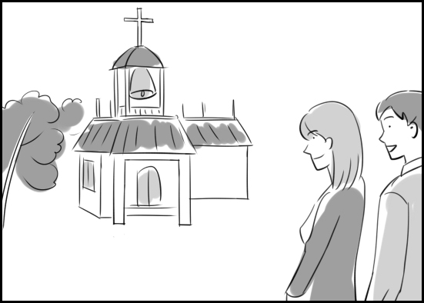
A.

1. ( )

2. ( )

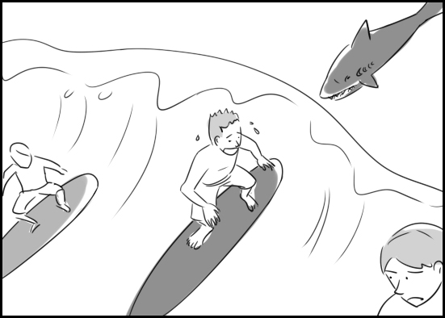
B.

3. ( )

4. ( )

II. Best Response 最佳回应句 – 28% 每题7分
Choose the best response to each question or statement.

5. A. He cut his hand accidently.
B. He dropped a few dishes.
C. He sailed into some rocks.
D. He forgot to lock his bicycle.

6. A. No, we get few visitors.
B. No, our salaries are fine.
C. No, I seldom go abroad.
D. No, the wine is delicious.

7. A. That course sounds entertaining.
B. He hung the picture on his wall.
C. It's his favorite mystery program.
D. I doubt the jury will believe that.

8. A. Yes, she's laying off several clerks.
B. Yes, she’s late for work sometimes.
C. Yes, she's increasing the room rates.
D. Yes, she wants the staff to be polite.

III. Short Conversations 简短会话– 24% 每题8分
Listen to the conversations. Then answer the questions.

9. A. Her supervisors are helpful.
B. Security there is very tight.
C. It's quite short of funds.
D. It's many miles away.
10. A. A good practice. B. A fine harvest.
C. A useful meeting. D. A fun vacation.

11. A. Who the crime was committed by.
B. When the crime was committed.
C. Where the crime was committed.
D. Why the crime was committed.

IV. Short Talk 短文 – 24% 每题 12 分
Listen to the talk. Then choose the best answer to each question.

12. A. Purchasing a fast vessel.
B. Owning his own business.
C. Investing in rural property.
D. Negotiating a stock price.

13. A. His health has been suffering.
B. His taste in cars is interesting.
C. He has a great deal of wealth.
D. He works for a travel agency.

Reading Section
I. Vocabulary 词汇 – 27% 每题 3 分
Choose the word or phrase that best completes the sentence.

1. Only a few high-ranking officials have __________ to enter this part of the White House.
A. obstacle B. clearance
C. vehicle D. participle

2. According to the police, Mr. and Mrs. Jones sailed away from the __________ on their boat at about 8:00 this morning.
A. proverb B. shaver
C. objection D. marina

3. The wealthiest person I've ever met is a __________ named Sam Becket.
A. settlement B. regulation
C. billionaire D. machinery

4. Centuries ago, this was a __________ site where people worshiped together.
A. talkative B. delighted
C. willing D. religious

5. If the wind isn't too strong, we'll __________ from the top of that cliff down to the beach.
A. paraglide B. isolate
C. manufacture D. summarize

6. According to the sign, there's no __________ today because the waves are dangerously high.
A. winking B. regarding
C. rotting D. surfing

7. What could be the young woman's __________ for stealing her friend's diary?
A. slipper B. motive
C. patience D. triangle

8. Holding a door open for a lady is one way to show __________.
A. broadcast B. courtesy
C. experiment D. shepherd

9. That man is serving at least fifteen years in prison for __________ a small child.
A. kidnapping B. postponing
C. encountering D. interacting
II. Cloze Test综合测验 – 30% 每题 5 分
Read the passage and fill in each blank with the correct word or phrase.
For people who can afford them, expensive yachts offer travel in style!
Seven Seas is an 86-meter-long superyacht owned by movie director Steven Spielberg. On __(10)__, there is a special glass wall not far from the on-deck pool. The glass doubles as an outdoor movie screen, allowing Spielberg and his guests to enjoy movies while __(11)__ in the pool.
Designed in part by Steve Jobs, Venus is an 80-meter-long yacht that features an aluminum __(12)__ and lots of glass. The sleek yacht calls to __(13)__ Apple’s famous designs. If you look up to the wheelhouse, you’ll see the screens for the 7 iMac computers used to control the remarkable __(14)__.
Another superyacht looks more like a submarine than a yacht. Owned by Russian businessman Andrey Melnichenko, it's named simply A. Almost 200 meters long, A features a master bedroom that is only __(15)__ by fingerprint scan. This means that it’s off limits to you and me, as is the US$300 million price tag!

10. A. queue B. center
C. figure D. board
11. A. voyaging B. funding
C. retreating D. soaking
12. A. dye B. bait
C. hull D. fax
13. A. mind B. place
C. form D. hint
14. A. impact B. punch
C. vessel D. flame
15. A. untouched B. accessible
C. mysterious D. economical

III. Reading Comprehension阅读理解–30%每题6分
Read the paragraph. Then answer the questions.
On a map of the world, the Azores may be a little hard to spot. This small volcanic island group lies 1,815 kilometers west of Europe, right in the middle of the Atlantic. But don’t judge the Azores by their size. These nine Portuguese islands offer a wonderful off-the-beaten-path experience.
The Azores were first discovered by Portuguese explorers in 1427. People began to settle on the islands a few years later. The economy grew as European and African countries began to trade with the islands. Their rich soil was the perfect place to grow wheat, sugar and fruit. The people who lived there, called Azoreans, were brave people. They survived in spite of natural disasters, pirate attacks, war and invasion. Today the Azores are an important source of trade with Europe. They’re also a favorite vacation spot for visitors, who give the local economy an important boost.
One of the Azores' popular attractions is Furnas, a community located on top of a volcano. Furnas' residents don't worry about the volcano since it hasn't been active since 1630. Inside the volcano is a warm, spring-fed lake. Brown in color, the lake is a popular place to bathe because of the healthy minerals it contains. From openings in the ground around the lake, hot steam and gases rise into the air. Restaurants in the nearby town of Furnas use these openings as natural ovens. After combining several kinds of meat with sausage and vegetables, a cook places the food in a large covered pot, which he then lowers into an opening, where it cooks for five to seven hours. The result is a delicious dish called cozido that visitors never fail to enjoy.

16. Which of the Azores' industries does this article discuss?
A. The grocery industry
B. The tourism industry
C. The communications industry
D. The real estate industry
17. What do we learn about the Azores' native people?
A. How they keep very fit
B. How they modified crops
C. How courageous they were
D. How long they typically live
18. What did Europeans discover about the islands after they began to settle there?
A. That they contained precious metals
B. That they were suitable for agriculture
C. That their climate posed a challenge
D. That their population had declined
19. According to this article, what do restaurants in Furnas take advantage of?
A. Heat in the earth B. A yearly festival
C. Quite low wages D. Abundant seafood
20. What does the article imply about the volcano?
A. It will explode soon.
B. It causes a lot of anxiety.
C. It's inspired overseas artists.
D. It's considered to be safe.

IV. Translation中译英 – 13% (每格1分)

21. 尽管经济不佳，在这区的房子已相当快速地被卖出。
Houses in this __________ have been selling fairly quickly __________ __________ __________ __________ __________ __________.

22. 鲜少人们造访那座国家公园，因为那里非常地人迹罕至。
Few people visit that national park because it's __________ __________ __________ __________ __________ __________.

V. Bonus 加分题 – 10%
23. 不与警方合作，相反地，这个嫌疑犯逃到另一个国家去。(Instead of…)
______________________________________________________________________________
Listening Section
I. Pictures 看图辨义 – 24% 每题6分
Listen to the questions. Then choose the best answer according to each picture.

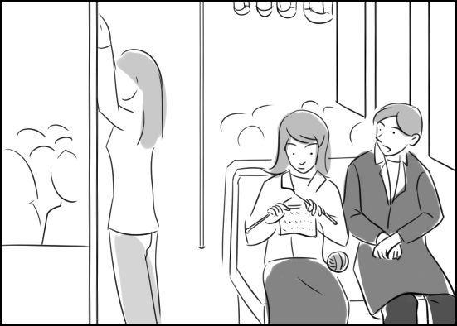
A.

1. ( )

2. ( )

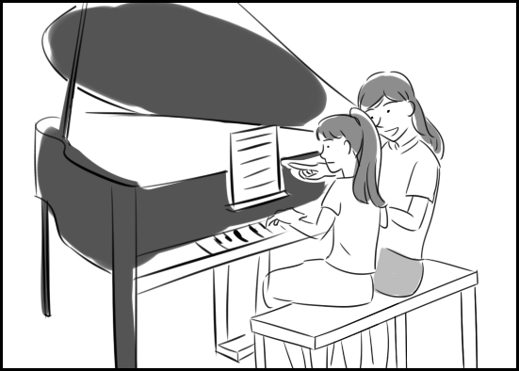
B.

3. ( )

4. ( )

II. Best Response 最佳回应句 – 28% 每题7分
Choose the best response to each question or statement.

5. A. I'd be happy to help!
B. Yes, it's tomorrow.
C. Well, congratulations!
D. That class is starting.

6. A. It isn't time for a break yet.
B. I'm enjoying the holiday, too.
C. Don't give up on your dreams.
D. Maybe it needs a new battery.

7. A. Tennis. B. Saturday.
C. Hamburgers. D. Blue jeans.

8. A. No, they're too old.
B. No, they're still green.
C. No, they don't grow well.
D. No, they aren't on sale.

III. Short Conversations 简短会话– 24% 每题8分
Listen to the conversations. Then answer the questions.

9. A. He can't get to work on time.
B. He hasn't been sleeping well.
C. He feels like he has the flu.
D. He's under a lot of pressure.
10. A. At a medical supply firm.
B. At a discount food market.
C. At a home appliance store.
D. At a small stationery shop.

11. A. A speech contest.
B. A student play.
C. A musical event.
D. An athletic competition.

IV. Short Talk 短文 – 24% 每题 8 分
Listen to the talk. Then choose the best answer to each question.

12. A. They love all kinds of art.
B. They're interested in plants.
C. They enjoy math problems.
D. They're curious about ships.

13. A. They're sold on the Internet.
B. They're used to make robots.
C. They contain electronic parts.
D. They come in different sizes.

14. A. Only one. B. Two is enough.
C. At least three. D. No less than four.

Reading Section
I. Vocabulary 词汇 – 36% 每题 4 分
Choose the word or phrase that best completes the sentence.

1. Next Monday is the __________ for turning in our science reports.
A. behavior B. imitation
C. deadline D. criticism

2. I wonder what happened to the __________ for that jazz band.
A. survival B. pianist
C. sake D. midday

3. Recovering from a serious head injury can be a slow and difficult __________.
A. sorrow B. nationality
C. violation D. process

4. Let's practice the __________ of that song a few more times.
A. grave B. refrain
C. liquor D. crutch

5. Michael loves to perform classical ballet, but he doesn't fit the __________ of a ballet dancer.
A. stereotype B. destination
C. enlargement D. friendship

6. Cycling has been a popular form of __________ for more than a century.
A. parliament B. landmark
C. recreation D. modesty

7. That shop sells a __________ variety of chocolate candies.
A. disadvantaged B. consequent
C. mouthwatering D. psychological

8. This two-hundred-year-old church has been __________ a historic site.
A. meant B. declared
C. forbidden D. subtracted
9. This type of fruit is rich in __________ and minerals.
A. instincts B. facilities
C. leopards D. vitamins

II. Cloze Test综合测验 – 30% 每题 5 分
Read the passage and fill in each blank with the correct word or phrase.

Shailene Woodley started getting acting parts in numerous commercials as a child. Her parents gave her three guidelines as an actor: to stay __(10)__ to herself, have fun and do well in school. Accepting this __(11)__, Woodley took on commercials which were soon replaced with TV shows such as The O.C. and CSI: NY while __(12)__ in school.
High school proved to be eventful for Woodley in both good and bad ways. First, she learned she had scoliosis, which put her in a __(13)__ for about two years to straighten her back. When she was 15 years old, her parents were divorced. Soon after, she was __(14)__ as the resolute lead in The Secret Life of the American Teenager. Her life experiences helped her relate to her role in the show, which dealt with many teen issues. All the while, Woodley did schoolwork between __(15)__ as she filmed for 30 to 50 hours per week. Since then, she has played roles in two movies, The Descendants and Divergent.

10. A. flat B. true
C. mild D. keen

11. A. challenge B. instrument
C. expression D. procedure

12. A. bandaging B. remaining
C. shuttling D. motioning

13. A. cradle B. figure
C. route D. brace

14. A. felt B. bitten
C. cast D. told

15. A. lungs B. webs
C. takes D. signs

II. Reading Comprehension阅读理解–24%每题6分
Read the paragraph. Then answer the questions.

Mangoes are more than just fruit. They also contain large seeds. Inside each seed is a soft "kernel." Manufacturers remove these kernels from dried mango seeds and process them to make a soft, creamy material called "mango butter."
Raw mango butter is a popular ingredient in many personal care items. These include lotions, shampoos, lipstick and even soap.
When lotion containing mango butter is applied to skin, moisture from the lotion enters the skin and softens it. At the same time, the lotion smoothes out wrinkles, making the skin look younger. Mango butter lotion can also protect skin from the sun's harmful rays. For this reason, many people apply mango butter to their skin before going outside on hot summer days.
Mango butter has a similar effect in shampoos. When a shampoo containing mango butter is used, it puts moisture into the hair. This strengthens the hair. As a consequence, the hair looks shiny and healthy, and individual strands of hair are less likely to break.
Some brands of lipstick also contain mango butter. Besides coloring lips, these lipsticks smooth and soften them by adding moisture.
Many types of soap are hard on skin. But soap containing mango butter is not. Instead, it not only cleans skin but also puts moisture into it. For this reason, some men use mango butter soap before shaving. The mango butter smoothes the skin and prepares it for the razor.

16. What is discussed in this article?
A. Commercial applications of mango butter
B. Several opposing views on mango butter
C. A scheme for advertising mango butter
D. The misunderstood origin of mango butter

17. What does this article explain about mango butter?
A. Why few consumers buy it
B. How it is commonly produced
C. When sales of it peak every year
D. Where it can be safely stored

18. What does mango butter do for skin?
A. It gives it a nice brown color.
B. It removes spots from it.
C. It heats it up rapidly.
D. It keeps it from getting dry.

19. According to this article, where do men specifically use mango butter soap?
A. On their legs B. On their faces
C. On their hands D. On their arms

IV. Translation中译英 – 10% (每格1分)

20. 你在工作中额外投入的时间与努力，最后将会有所回报。
The extra time and effort that you put into your job will __________ __________ __________ __________ __________.

21. 这些吉他乐曲应该相当容易凭记忆学习。
These guitar pieces should be fairly __________ __________ __________ __________ __________.

V. Bonus 加分题 – 10%

22. 搭乘长途巴士或火车时，编织是杀时间很好的方式。
______________________________________________________________________________

